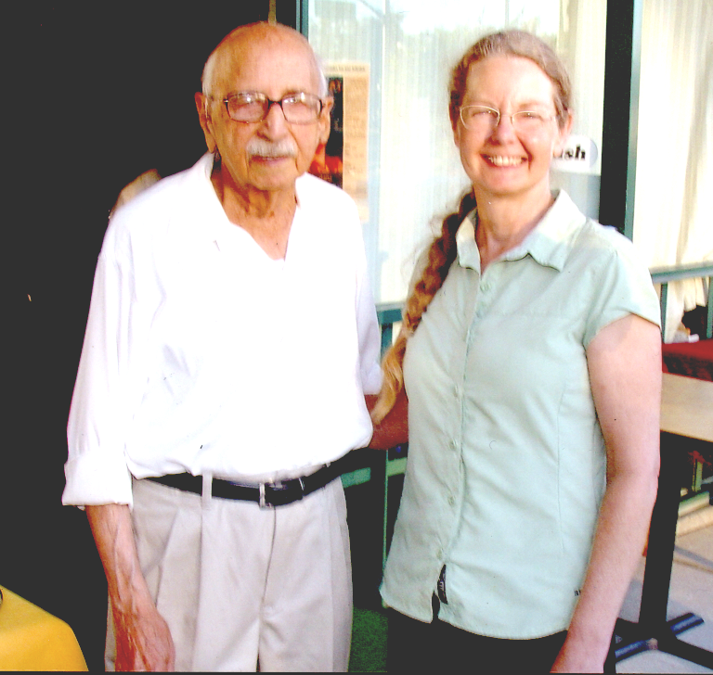
JACKIE AND SINDHI

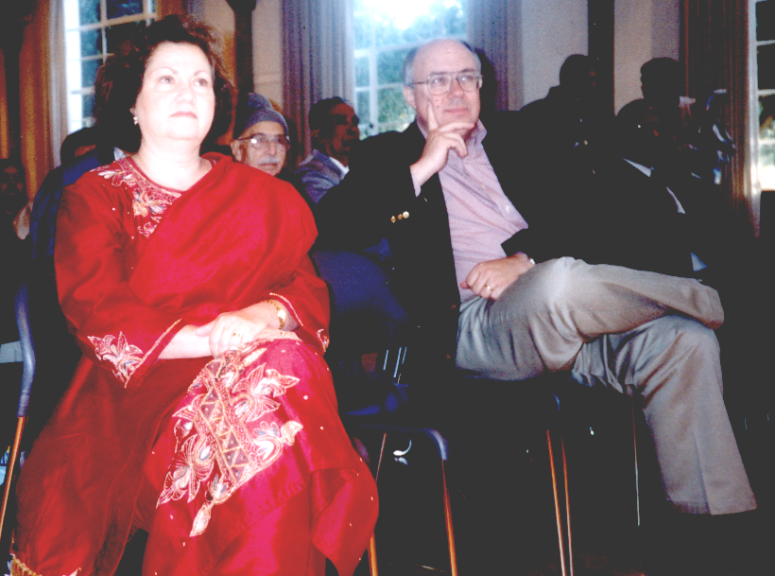
SENETORS ELLAIN AND SIMITAN


SUGHOSH AND NENCY

